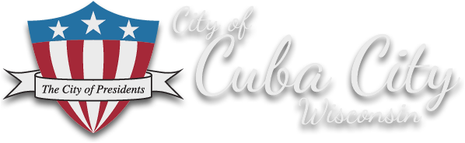

Cuba City Presidential Plaza Award Ceremony Agenda

Wednesday, November 10th 1:00 pm
Cuba City Common Council Chambers
108 N Main Street, Cuba City, WI 53807
608-744-2152
www.cubacity.org

- Opening Remarks Bob Jones, CC Economic Development Director
- Overview John Van De Wiel, Cuba City Mayor
- Community Perspective Donna Rogers, City of Presidents Committee
- UW-P Participation Dr. Kristina Fields, UW-P
- Before/After Slides Bob Jones
- AARP Community Challenge Grant Sam Wilson, AARP Wisconsin State Director
- WEDC Main Street Award Errin Welty, WEDC Downtown Development
Director
- Wisconsin Rural Partners Award Sandy Decker, President, Wisconsin Rural Partners, Inc.
- Closing Remarks Mayor Van De Wiel

Tour of the Presidential Plaza, 211 S. Main Street, Cuba City

