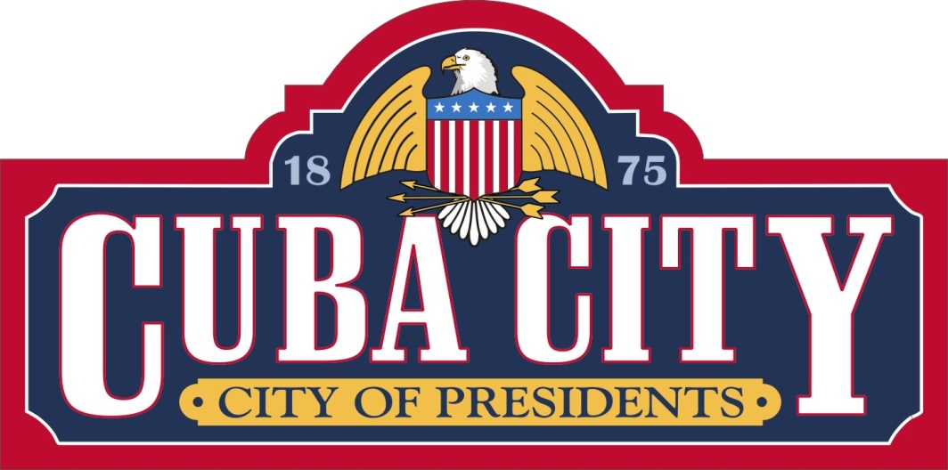

Cuba City Report on the AARP Community Challenge Grant 2020

Section I. Introduction
The City of Cuba City is pleased to report on the many positive impacts that have already resulted from our recent Presidential Plaza project. Thanks go to AARP, AARP Wisconsin and our many other partners who have made the Plaza a reality for our community. The project relied on a wide range of partnerships including the City of Presidents Committee, the Cuba City Telephone Company, the University of Wisconsin-Platteville (UW-P), the Cuba City Schools and several private entities. It is expected that the Plaza will provide our community with the intergenerational gathering place that has been long sought here. In addition, this vibrant living space will serve as a tourism draw that will benefit our Main Street businesses for years to come.
The Covid-19 pandemic, along with the late start to the project, which was announced on August 20th, presented many challenges to this undertaking. However, our partners provided great support and understanding with regard to these issues.
The Plaza is a permanent addition to our award-winning Main Street and this project will be nominated for the Wisconsin Economic Development Corporation’s Main Street Award contest in early 2021.

Section II. Specific Project Elements
This section will address the elements highlighted in the MOU, in the order that was depicted on that form.
1/2. Parking Lot Excavation, Sod and Trees
The Presidential Plaza project permitted us to remove a seldom used gravel parking lot that had become an eyesore and dumping grounds for both trash and abandoned vehicles.
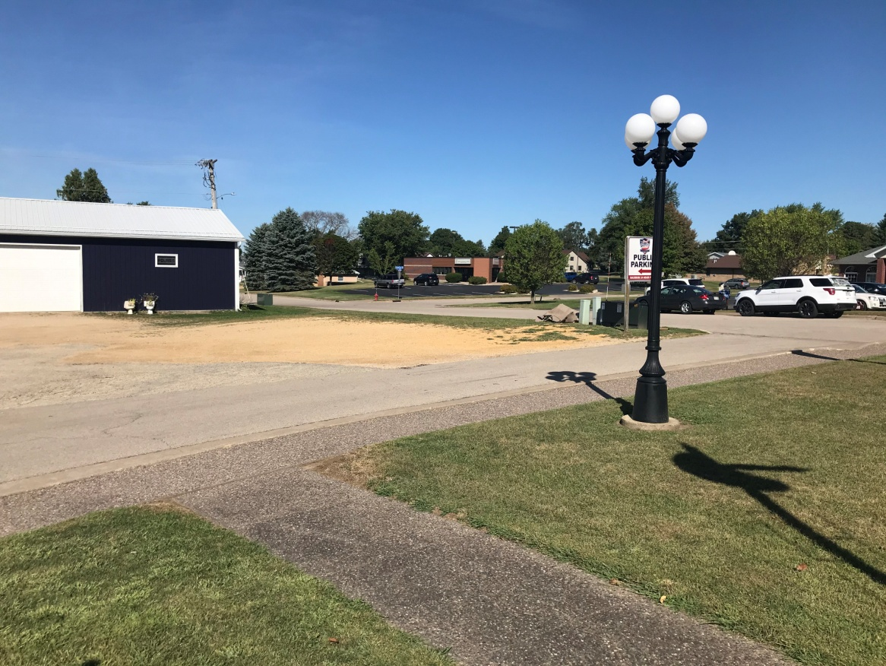
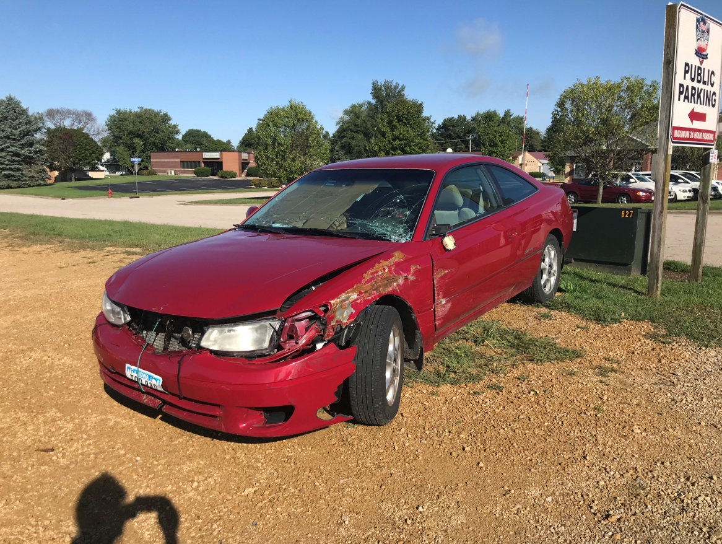

The area has been excavated and high quality sod was added along with new trees.
There are three Norway Spruce trees along with a lilac and a pear tree. The latter two will add their pleasant seasonal scents to the Plaza area. The new sod has been very well received by residents will be a great addition to the City’s very popular Community Market which is held at this location spring through fall.
It should be noted that not all residents were in favor of the project. Interestingly it was the more vocal of these individuals who took the time recently to adorn all five new trees with ornaments and Christmas lighting.
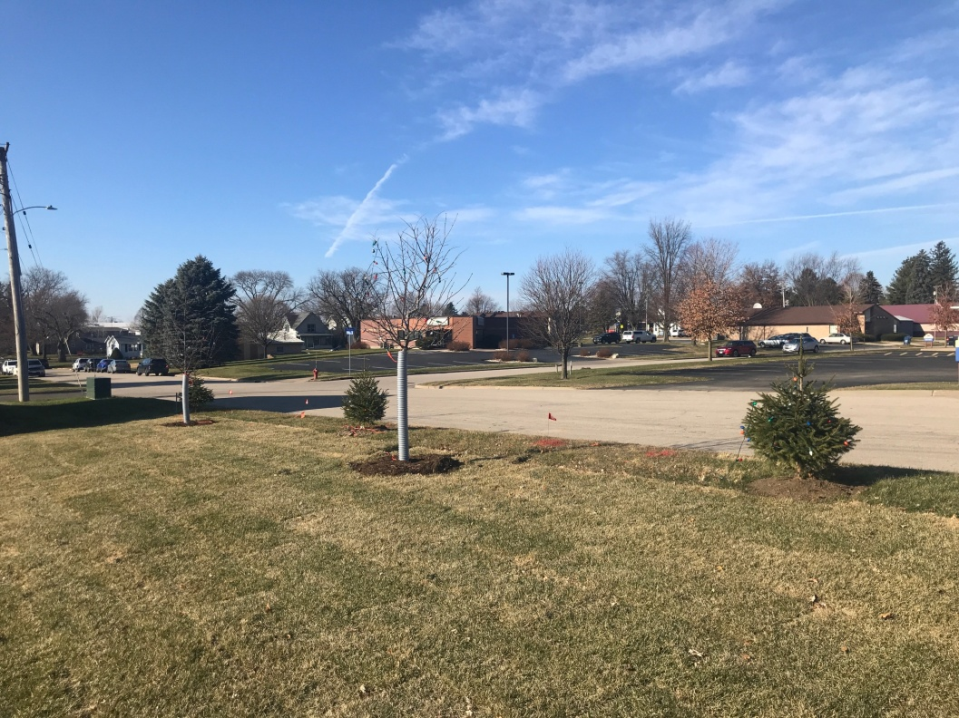
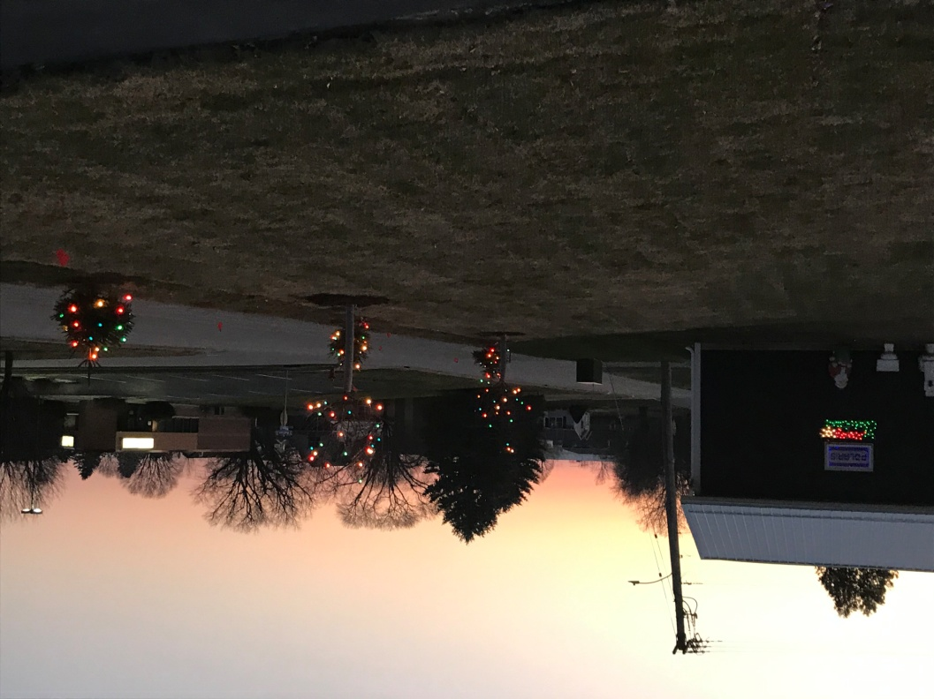

3. Replacement of Three Curb Ramps
The replacement of the three adjacent sidewalk ramps proved to be a huge challenge to this project. Last spring, our UW-P Senior Design Team estimated the cost to replace the existing ramps with ADA Compliant ramps at $2,300.00. The actual cost was $15,791.50 including the engineering fees and concrete work. The assistance of AARP Wisconsin as well as a few project cost savings permitted us to complete these upgrades.
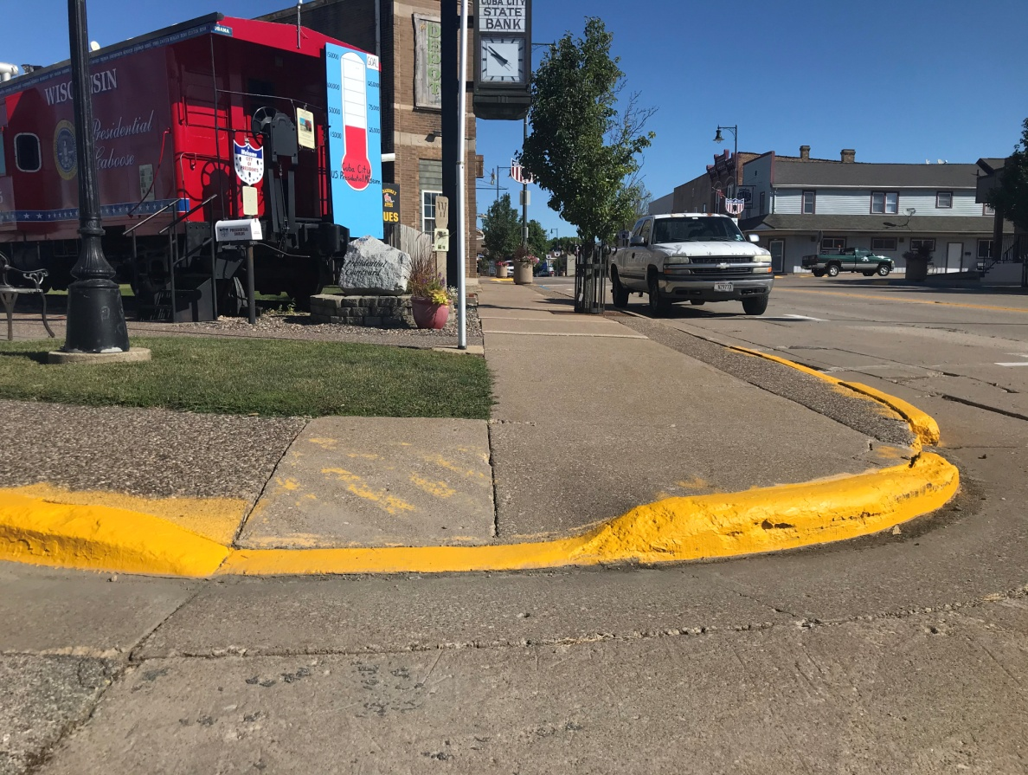
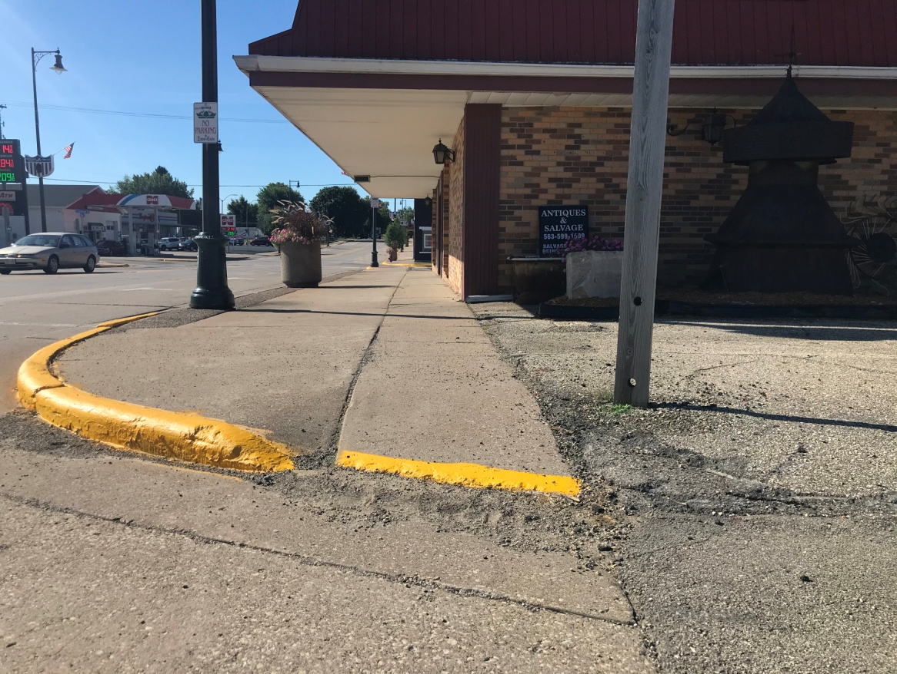
The sidewalk ramp by the Presidential Caboose (middle photo) required southbound handicapped individuals to veer left on their scooters, then right, then left and right again.

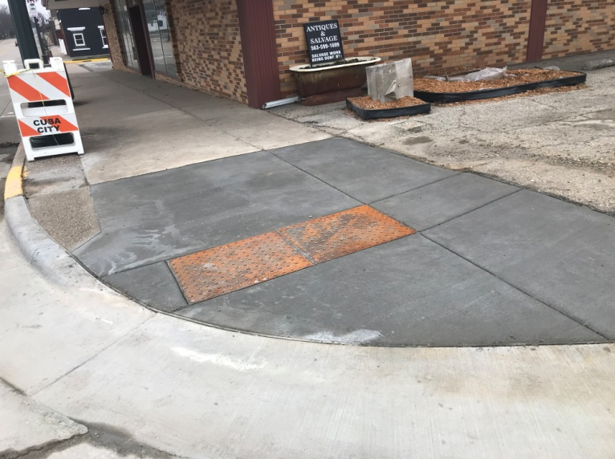
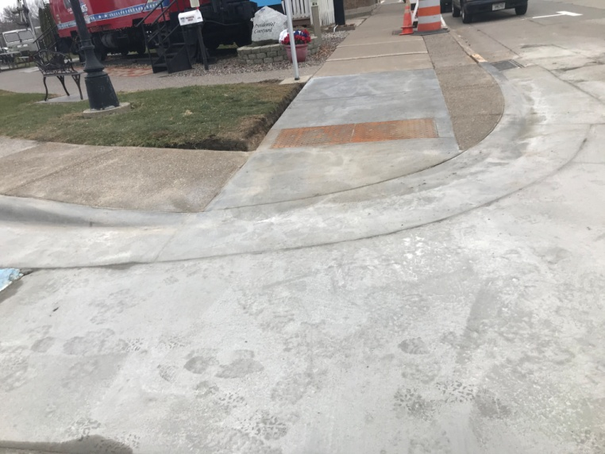
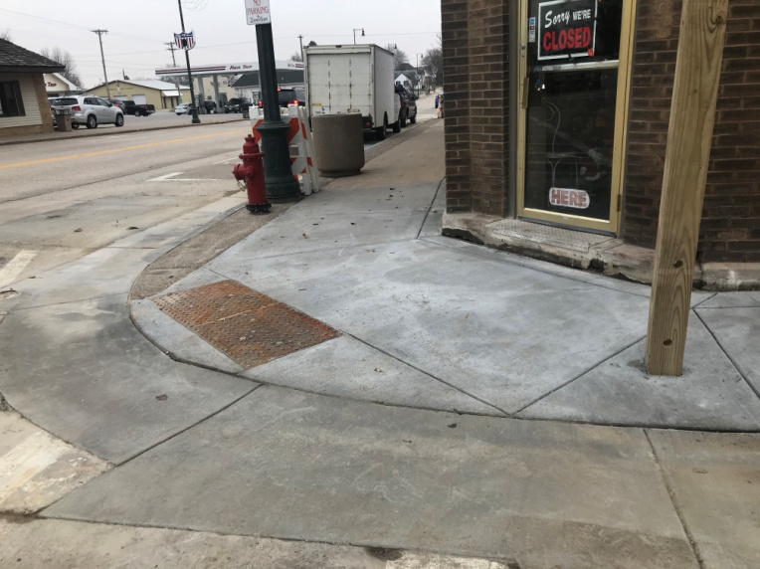

4. 700 Square Foot Ground Mural
The City’s partnership with the University of Wisconsin-Platteville (UW-P) was a key element in this project. We began working with UW-P in January of 2020, and despite the challenges presented by the pandemic, we were able to create a 10 year vision for the space. Using that vision as a guide, we were then able to submit a successful AARP Community Challenge grant application. In addition, the UW-P Art Department was able to assist in the mural portion of the project at a significant savings over a commercial artist. Thanks to this partnership, the 700 square foot mural was expanded to 4,200 square feet. University and Cuba City High School Art students were able to assist in the painting as this was out of doors and allowed for social distancing at the same time. The costs savings were then applied to the ADA ramp overruns.

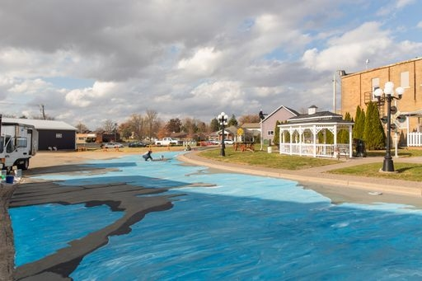

The mural is of the upper Mississippi River and is 3 dimensional when viewed looking to the west. It also has several interactive elements including a Presidential hopscotch area featuring the first 10 Presidents, an area for chalk art and the ability to “surf” the Mississippi on a 3D Presidential Shield. The mural also contains a salute to the Covid-19 frontline heroes and a thank you to AARP and our other generous donors.

A ground mural was selected because it is both innovative and interactive. Unlike wall murals, a ground mural requires visitors to exit their vehicles to view the artwork. This is expected to add to the traffic seen by our Main Street businesses.
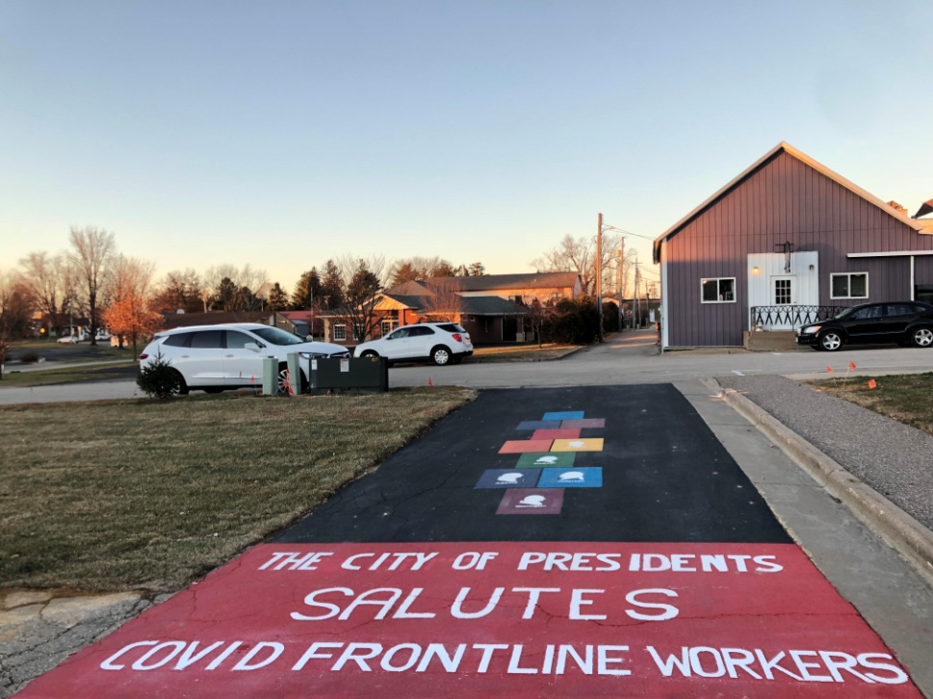
5. Wi-Fi Hotspot
The addition of a free Wi-Fi location at the Presidential Caboose was provided by our local telephone company. This portion of the project was subject to unexpected challenges due to the derecho that hit Iowa in the late summer. Despite the staffing issues, the Wi-Fi was active by Labor Day and it will be a useful draw to the Plaza.
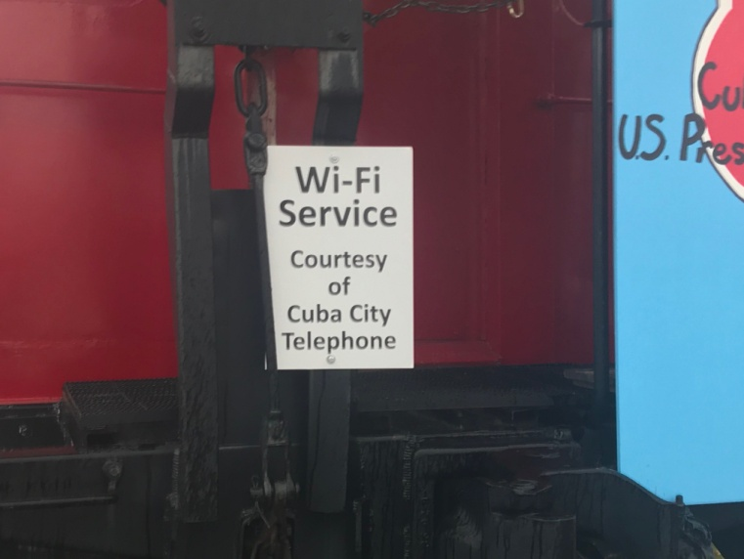

6. Games and Activities
Among the purchases for the Plaza were three round, wooden picnic tables/bases and LED solar powered lighted umbrellas, games and chalk. The games include ladder toss, bags and Spikeball. A bicycle rack was fabricated by a local welder and the high school construction class built a storage shed for the Plaza. The storage shed will be fitted with acrylic panels this spring to display our high school and elementary student art. It will house the games, hand wash station, sidewalk chalk and umbrellas when not in use.
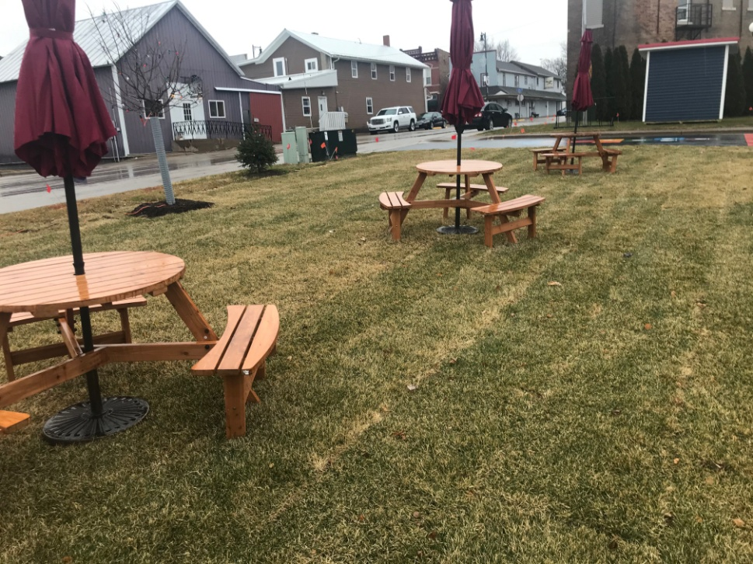

The three picnic tables are expected to provide a pleasant outdoor dining option that will provide a boost our downtown food businesses.
The Bluetooth Sound system at the Gazebo was useful for our Christmas Glow celebration as the parade terminated at the Plaza. Unfortunately, due to Covid restrictions, the events were limited but seasonal music was heard throughout the Plaza area and enjoyed by those in attendance.
UW-P is now completing the study of a bicycle/walking path for Cuba City. The planned course will include the Plaza, while the bicycle rack will permit the short term storage of bicycles for visitors to the downtown area.

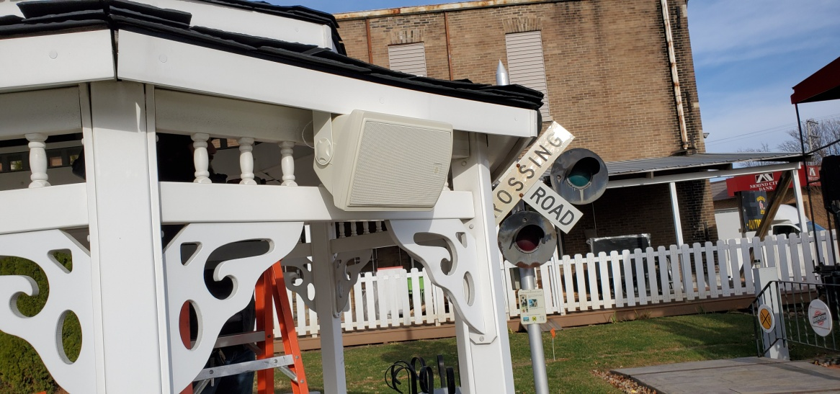

7. Donor Recognition
Thank you signage is on display across the Plaza area. In addition to the thank you sign shown here, we thanked our donors on the mural while tags and stickers thanking AARP have been attached to the tables, shed and games.

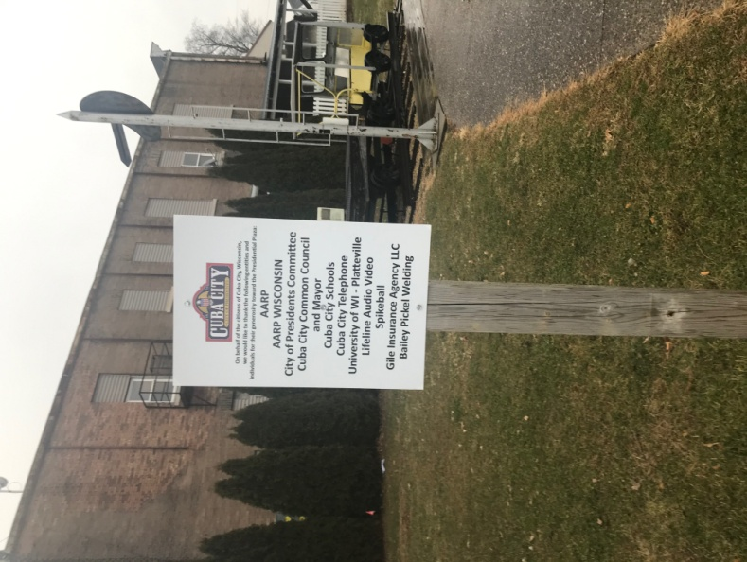

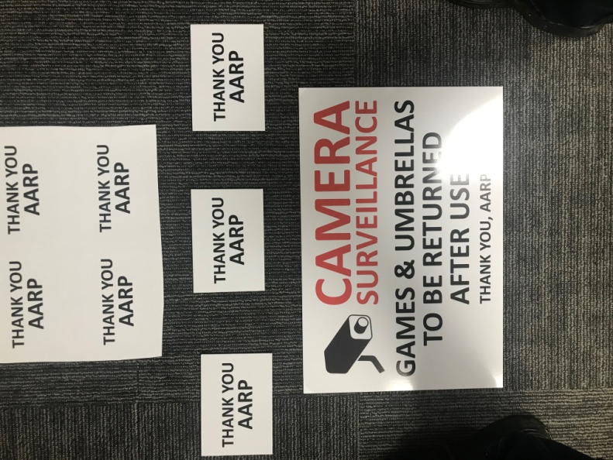
8. Ongoing Public Relations Plans
Cuba City has a very active public relations program and we look forward to promoting this project as well as AARP and the other funders and partners who made this undertaking a reality. We have already been in discussion with our Wisconsin contacts from AARP and our local media has been notified that we will be making announcements in early 2021. We have also notified AARP with our intentions to submit the project to the Wisconsin Economic Development Corporation (WEDC) for their Main Street Best Downtown Revitalization Award for a Community under 5,000 in Population. Cuba City was the winner of this prestigious award in 2017, and we believe that this project is more than worthy of this award. In addition, once the pandemic permits larger gatherings, we plan to do an unveiling of the Plaza. If not before, we hope to do this at our first Community Market in May of 2021. Once we are permitted to host entertainment activities at the Plaza, we will ensure that AARP and our other partners are well recognized for their participation in this project. We hope to host music and comedy acts and also see the Plaza utilized for games and art once the pandemic restrictions are eased.

