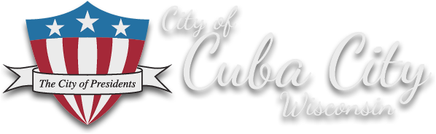

Contact information

Name: Bob Jones, Economic Development Director-Cuba City, Wisconsin
Cell: 815-281-2866
Email: cubacitycdc@gmail.com

Donna Rogers, City of Presidents 563-599-0098
Darrin Wasniewski, AARP 608- 286-6303
Aaron Olson, Cuba City Schools 920-979-2709
Bob Schmitt, UW-P 608-342-1239
John Van De Wiel, Cuba City Mayor 608-732-4704

Cuba City Recognized by Wisconsin Rural Partners for Top Rural Initiative

CUBA CITY, WI. Earlier this year, the City of Cuba City was recognized for its recent Presidential Plaza development with a Wisconsin Economic Development Corporation (WEDC) Main Street Program Award for Downtown Innovation. Now, Wisconsin Rural Partners (WRP) has awarded the “City of Presidents” with their Top Rural Development Initiative Award for the project.
For more than a decade, the residents of Cuba City have voiced their desire for a vibrant downtown community gathering space. A collaboration of the Cuba City School District, University of Wisconsin-Platteville, Cuba City Telephone, the City’s Downtown Task Force, AARP Community Challenge Grant Program, City of Presidents Committee, as well as several private businesses was key to the successful Main Street project, completed during the pandemic.

The project included new landscaping, seating, ADA-compliant walkways, free Wi-Fi, outdoor sound system, games, a unique 4200 square foot 3D interactive ground mural of the Mississippi River, and was accomplished without the use of city funds. The Plaza engages residents of all ages. Future events and activities are planned to increase downtown business traffic and draw visitors to Main Street. The Cuba City Community Market has grown substantially due to its location at the Presidential Plaza.

“Wisconsin Rural Partners applauds the Cuba City Presidential Plaza project as an outstanding example of the many local efforts across the state that improve the lives of citizens in rural Wisconsin,” said Sandy Decker, WRP President. “This is an excellent collaborative model for small rural Wisconsin communities.”

Partnering with the University of Wisconsin-Platteville’s (UW-P) Senior Design Team program brought the services of four senior engineering students into the project in early 2020. The Design Team provided a vision for how the area around the City’s Presidential Caboose on Main Street could be enhanced to create a community space, while also bringing traffic to the City’s downtown businesses. Working through the many challenges of Covid 19, the team also assisted in a grant application for AARP’s Community Challenge Grant, a program seeking innovative approaches to downtown revitalization that also has multi-generational aspects.
AARP received over 2,800 applications for the Grant and Cuba City was very pleased to be among the 184 communities nationwide to be awarded funding for their project.
Between the pandemic and the resulting shortages of construction and electronic equipment, the project did not progress as smoothly as first envisioned. “With considerable help from our many partners, we were able to complete the project before the December 18th deadline from AARP. AARP proved to be an outstanding partner, as were the many other organizations that assisted us in the project,” stated Mayor John Van De Wiel.
Cuba City is proud of its Main Street which can boast no empty storefronts and its daily average of 5,200 vehicles per day. The City also won the WEDC Main Street Award for a variety of improvements to its downtown in 2017.

