**Plaza Before and After Photographs**

Sidewalk Ramps

From Gravel to Green Space

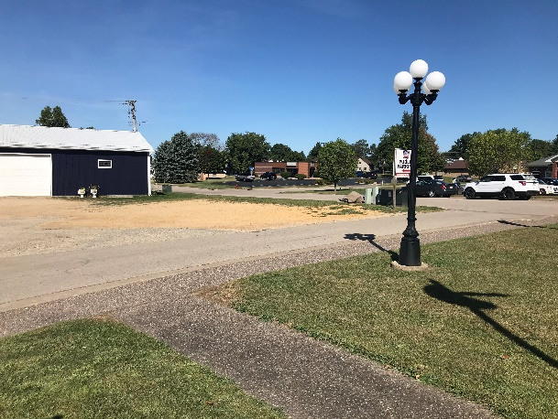 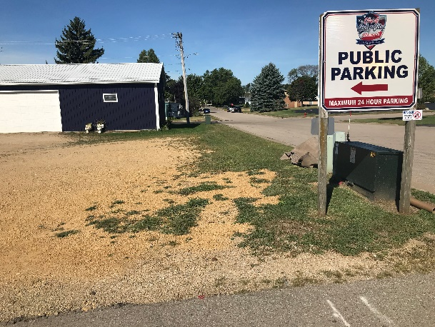

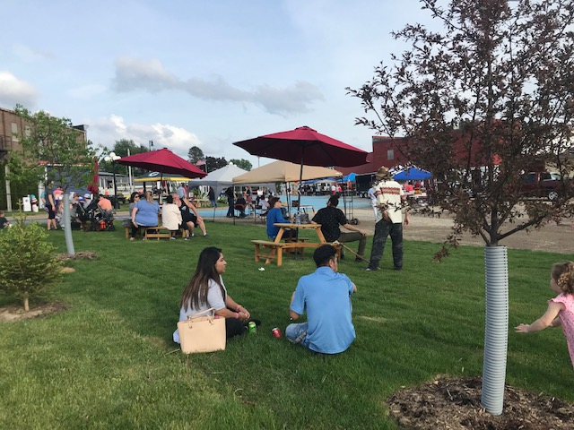

Community Market



